Vernacular Names: Grand Devil’s claw | Scientific Name: Pisonia grandis L.
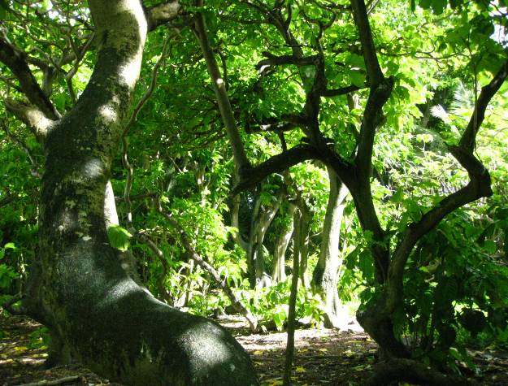  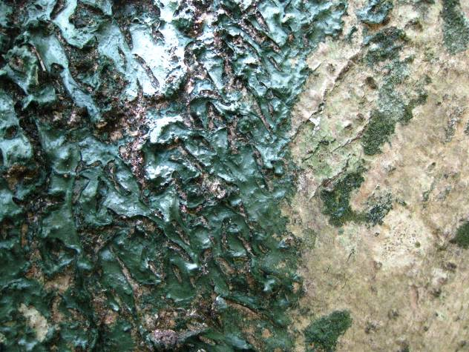 | 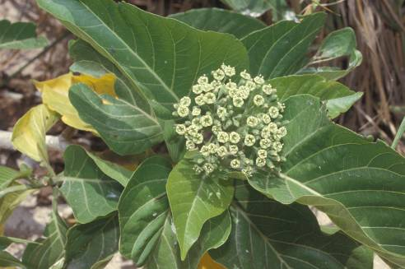  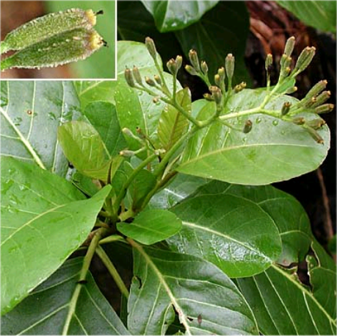
Full tree form & bark detail with lichen | Details of leaf, flower, & fruit
Native or Introduced: Native

Description: The tree has broad, thin leaves, smooth bark and bears clusters of green sweet-smelling flowers that mature into sticky barbed seeds. The bark is silvery-grey in colour, often bearing a grey-green patchy appearance, that may be a specialised lichen associated with this species? Fruits are not always present which can make its identification difficult. Flower heads can resemble Argusia’s, and large shiny leaves can resemble several other species. Fruit and bark characteristics are the best identifiers.

Habitat: The species often dominates mature coral cay vegetation, growing in dense stands up to 20 m (66 ft) tall. East Island, in the lagoon mouth at DG is now dominated by this tree.

Human uses: Pisonia wood is rather weak and soft and decays rapidly when the trees fall. Has been used in medicine, in particular in healing of wounds.

Significance: Pisonia forests are a common nesting site for seabirds. Also useful as a shade species as it forms a dense shrub cover.

Propagation: Natural dispersal occurs when seeds stick to bird feathers. Vegetative reproduction frequently results as fallen branches sprout or basal shoots develop into new trees.

